DS-471 Project
Deadline: Day 30/11/2026 @ 23:59
[Total Mark for this Assignment is 14]

Machine Learning
DS471

Instructions:
- You must submit two separate copies (one Word file and one PDF file) using the Assignment Template on Blackboard via the allocated folder. These files must not be in compressed format.
- It is your responsibility to check and make sure that you have uploaded both the correct files.
- Zero mark will be given if you try to bypass the SafeAssign (e.g. misspell words, remove spaces between words, hide characters, use different character sets, convert text into image or languages other than English or any kind of manipulation).
- Email submission will not be accepted.
- You are advised to make your work clear and well-presented. This includes filling in your information on the cover page.
- You must use this template, failing which will result in zero marks.
- You MUST show all your work, and text must not be converted into an image, unless specified otherwise by the question.
- Late submission will result in ZERO mark.
- The work should be your own, copying from students or other resources will result in ZERO mark.
- Use Times New Roman font for all your answers.

Name: ###  CRN: ### |  | ID: ###

DS-471 Machine Learning Project

Project Groups
Learning Outcome(s):
Instructors: State the Learning Outcome(s) that match this question

Students are required to complete a Machine Learning Project in groups of 3–4 students. Each group must have a maximum of four students.

Project Topics and Datasets
The purpose of this project is to apply the machine-learning concepts and techniques covered in the course to a real-world dataset. Each group must select one topic and its corresponding dataset from the list below:
Topic | Dataset link
Heart Disease Prediction | UCI Heart Disease
Breast Cancer Classification | UCI Breast Cancer Wisconsin (Diagnostic)
Diabetes Prediction | UCI CDC Diabetes Health Indicators
Diabetes Hospital Readmission Prediction | UCI Diabetes 130-US Hospitals
Obesity Level Prediction | UCI Obesity Levels
Heart Failure Prediction | UCI Heart Failure Clinical Records
Credit Card Default Prediction | UCI Default of Credit Card Clients
Bank Marketing Prediction | UCI Bank Marketing
Online Shopping Purchase Prediction | UCI Online Shoppers Purchasing Intention
House Price Prediction | UCI Real Estate Valuation
Household Electricity Consumption Prediction | UCI Individual Household Electric Power Consumption
Food Classification | UCI Dry Bean
SMS Spam Detection | UCI SMS Spam Collection
Email Spam Classification | UCI Spambase
Human Activity Recognition | UCI Human Activity Recognition Using Smartphones
Student Performance Prediction | UCI Student Performance
Network Intrusion Detection | UCI KDD Cup 1999 Data
Phishing Website Detection | UCI Phishing Websites
Air Quality Prediction | UCI Air Quality
Energy Efficiency Prediction | UCI Energy Efficiency

Project Stages

Stage 1: Data Cleaning, Preparation and Exploration (2 Marks)
Prepare the dataset for machine learning by:
- Understanding and describing the dataset, features, target variable, and data types.
- Identifying and handling missing values, duplicates, inconsistent data, and outliers.
- Applying appropriate encoding, scaling, and feature engineering.
- Performing exploratory data analysis (EDA) to identify important patterns, relationships, and target distribution.
- Identifying the most relevant features for predicting the target.
Important: Every data-cleaning, preprocessing, and feature-engineering decision must be explained and justified based on the characteristics of the dataset, the problem and the selected machine-learning algorithms.

Stage 2: Data Splitting (1 mark)
Divide the dataset into three separate sets:
- Training set: used to train the models.
- Validation set: used to monitor model performance and identify overfitting or underfitting during development.
- Test set: used only for the final evaluation of the selected models.
Students must justify their chosen data-partitioning ratio based on the size and characteristics of their dataset.

Stage 3: Model Selection and Development (3 marks)
Students must develop at least three appropriate machine-learning models, including the mandatory Neural Network.

Mandatory Neural Network!
A Neural Network is required for every project, whether the problem is classification or regression. Therefore, each group must use:
- One Neural Network
- At least two additional appropriate Traditional machine-learning models, including:
- Linear Regression
- Logistic Regression
- Support Vector Machine (SVM)
- Decision Tree
- Random Forest
- Ensemble Learning
Models must be appropriate for the selected problem. For example:
- Classification: Logistic Regression, SVM, Decision Tree, Random Forest, Neural Network
- Regression: Linear Regression, SVM Regression, Decision Tree Regression, Random Forest Regression, Neural Network
Students must explain why the selected models are appropriate for their dataset and problem.

Stage 4: Model Training and Hyperparameter Optimization (3 marks)
Train the selected models and optimize their hyperparameters using appropriate methods such as cross-validation.
Students must:
- Report and justify the selected hyperparameters.
- Monitor training and validation performance to identify overfitting and underfitting.
- Provide training and validation curves for the Neural Network.( I really want to see training/validation curves in the report!)
- Explain any overfitting or underfitting observed and how it was addressed.

Stage 5: Model Final Evaluation and Comparison (3 marks)
Evaluate the selected models using the test dataset and appropriate evaluation metrics. For classification problems, possible metrics include: Accuracy, Precision, Recall, F1-score, Confusion Matrix, and ROC-AUC. For Regression Problems, metrics include: MAE, MSE, RMSE, and R². Students must select and justify the metrics that are most appropriate for their problem.

Model Comparison
Provide a final comparison table showing the test performance of the selected models, including the Neural Network. Discuss the results and identify the model that is most suitable for the selected dataset and problem.

Project Deliverables
Each group must submit the following:

1. Jupyter Notebook / Google Colab
The notebook should document the complete machine-learning workflow, from data preparation to final evaluation, including:
- Data preparation and EDA
- Feature engineering
- Data splitting
- Model development
- Hyperparameter optimization
- Training and validation analysis
- Model evaluation and comparison
- Results and visualizations

2. Project Report
The report must provide a clear and detailed account of all project stages, including:
- Introduction: Problem definition and objectives
- Stage 1: Data preparation (2 marks)
- Stage 2: Data splitting (1 mark)
- Stage 3: Model selection and development (3 marks)
- Stage 4: Model training and hyperparameter optimization (3 marks)
- Stage 5: Model evaluation and comparison (3 marks)
- Discussion: Interpretation of results and comparison between the Neural Network and traditional machine-learning models (1 mark)
- Conclusion: Main findings and possible future improvements (1 mark)
All major methods, decisions, and results should be clearly explained and supported by appropriate tables and visualizations.

3. GitHub Repository
Each group must create a GitHub repository containing the project code and relevant files. The GitHub repository link must be included in the final project report.

Answer:
Topic: Breast Cancer Classification
Introduction
This project predicts whether a breast mass is malignant or benign from quantitative cell measurements. The objective is to prepare a real dataset, develop three classification models, control overfitting and compare their performance on observations held apart from development. Malignant is the positive class throughout, so recall describes the proportion of malignant cases detected.
The neural network was selected before test evaluation using validation F1. Logistic regression obtained the highest test F1 in this run. The difference is small and does not establish a general advantage on new populations. All findings describe a retrospective educational benchmark.
Stage 1 Data cleaning preparation and exploration
The dataset contains 569 observations and 30 continuous predictors. The measurements come from digitized fine needle aspirate images. Ten cell properties—radius, texture, perimeter, area, smoothness, compactness, concavity, concave points, symmetry and fractal dimension—each have mean, standard error and worst summaries. The target is diagnosis. The source contains 357 benign and 212 malignant cases, or 62.74% and 37.26%, respectively (Wolberg et al., 1993).
The data were loaded through scikit-learn’s bundled copy of the UCI dataset. This copy excludes the source identifier, avoiding an irrelevant ID predictor. Its target coding is reversed in the notebook: original malignant 0 becomes 1, and benign 1 becomes 0. Predictor columns are float64; the recoded binary target is an integer (scikit-learn developers, n.d.-b).
Integrity check | Observed result | Decision
Missing or infinite entries | 0 | No imputation
Duplicate predictor rows | 0 | No duplicate removal
Constant or negative predictors | 0 | No correction needed
Target labels | Only 0 and 1 | Valid binary classification

All observations were retained. Training-only Tukey fences flagged 100 of 341 rows and 351 individual cells. Extreme measurements may represent meaningful malignant morphology rather than recording errors, so trimming or winsorizing them would risk discarding useful cases. Zero measurements were retained as valid nonnegative observations. These checks establish internal consistency but cannot verify measurement accuracy against original clinical records.

Stage 1 Exploratory analysis and preprocessing
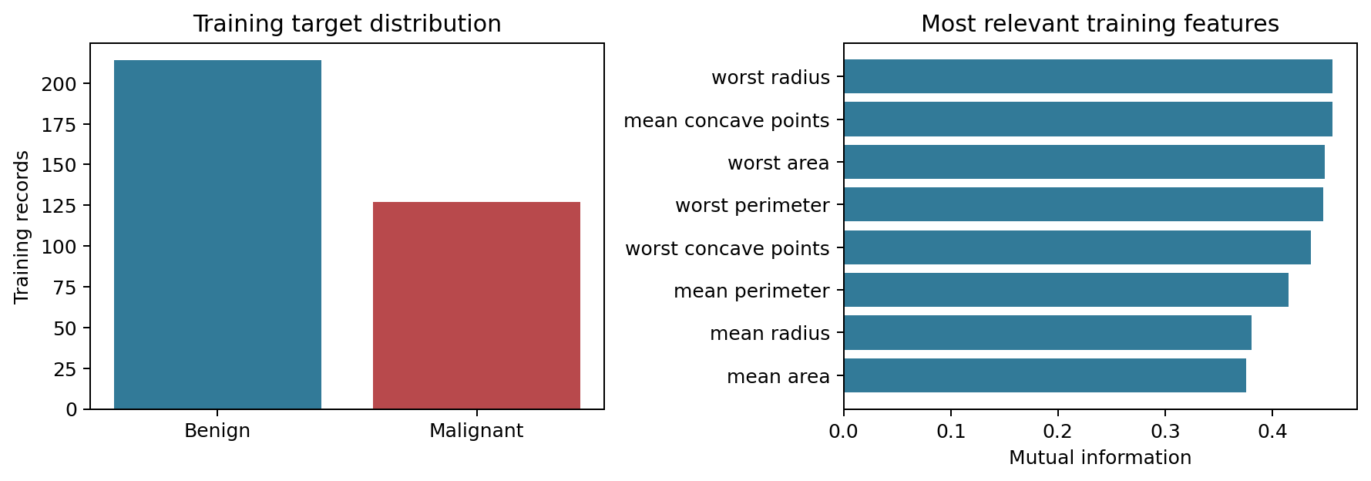
Figure 1 Training class balance and the eight highest mutual information scores
The training split contains 214 benign and 127 malignant cases. This moderate imbalance makes accuracy insufficient by itself, although it does not justify synthetic oversampling. Mutual information was calculated only from training records and describes univariate predictive relevance; it is not a causal importance measure.
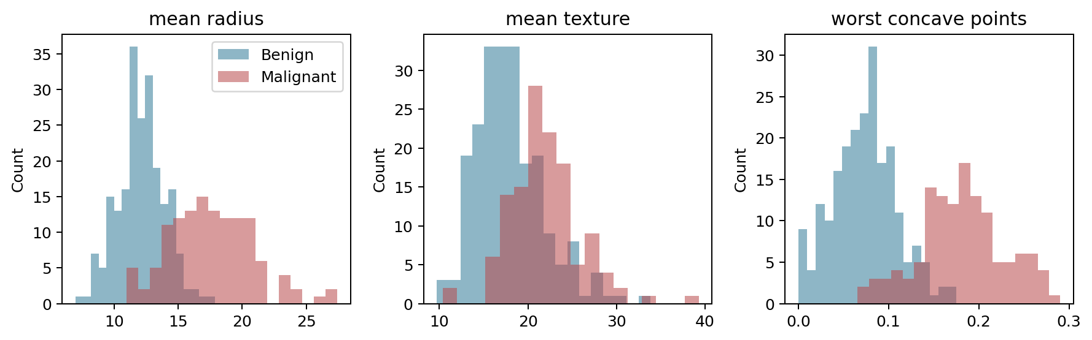
Figure 2 Training feature distributions by diagnosis
The distributions show class separation in size and concave-point measurements, with overlap that prevents a single measurement from perfectly classifying every case. Texture adds another dimension of variation. All 30 supplied predictors were retained because they represent complementary summaries and the dataset is small; no arbitrary ratios or polynomial terms were introduced.
Feature engineering consists of standardized measurements for logistic regression and the neural network: z = (x − training mean) / training standard deviation. Scaling prevents large-unit area measurements from dominating optimization. StandardScaler is fitted separately inside each training CV fold, then on the complete training split for the selected model. Forest predictors remain unscaled because tree split ordering does not depend on linear unit changes. No categorical predictor encoding is required.
Stage 1 Relationships and relevant features
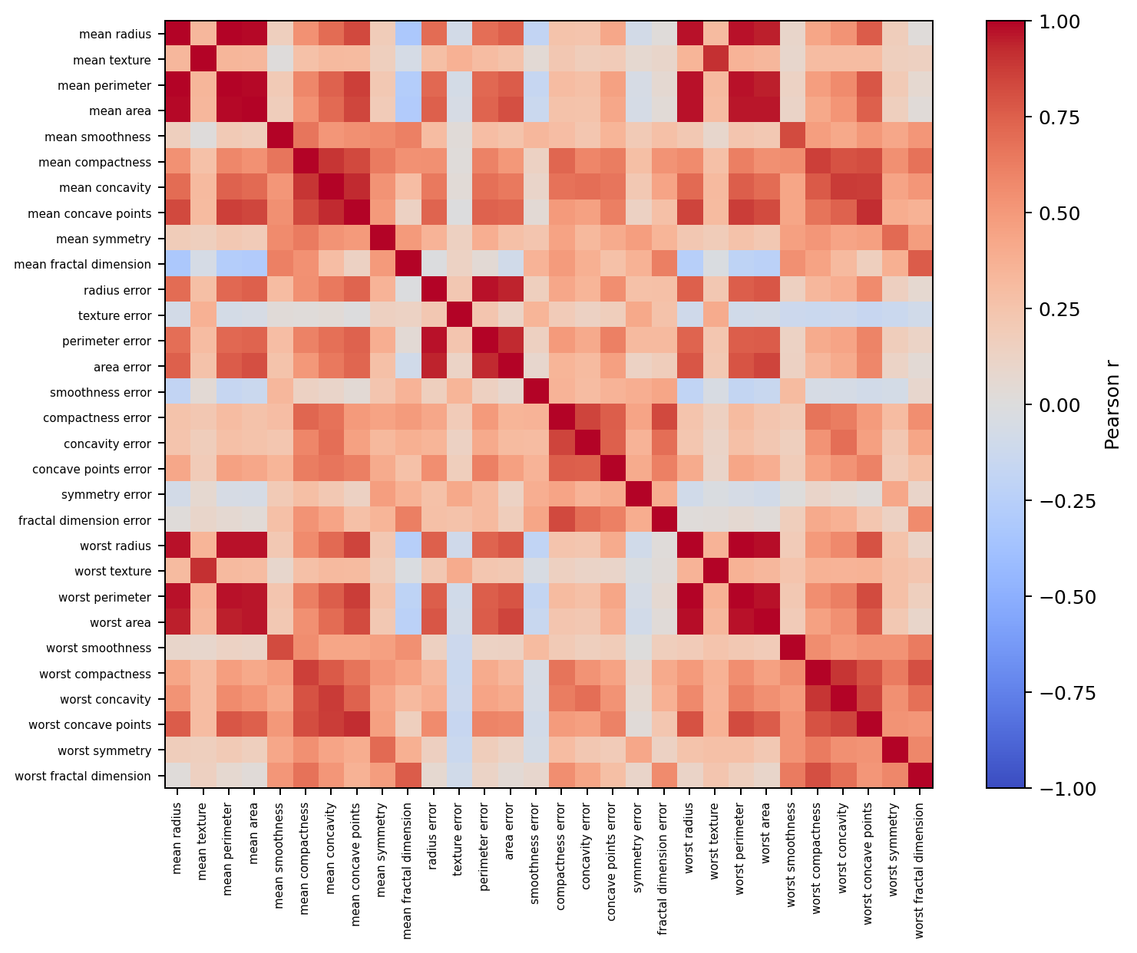
Figure 3 Pearson correlation matrix calculated only on training observations
Mean radius and mean perimeter have the strongest absolute training correlation, r = 0.9978. Several size summaries contain overlapping information. Keeping them maintains a common input set across models; L2 penalties in logistic regression and the neural network constrain coefficient growth, while forest tuning examines complexity restrictions. Correlation alone does not justify dropping a predictor without validation.
Rank | Training feature | Mutual information
1 | worst radius | 0.4565
2 | mean concave points | 0.4564
3 | worst area | 0.4490
4 | worst perimeter | 0.4476
5 | worst concave points | 0.4359

These rankings identify the strongest measured univariate relationships in this training subset. They are descriptive only: no feature-selection rule was fitted using validation or test outcomes. Correlated predictors can share information, so their ranking should not be interpreted as independent contributions.

Stage 2 Data splitting
Partition | Records | Benign | Malignant
Training | 341 | 214 | 127
Validation | 114 | 71 | 43
Test | 114 | 72 | 42

A stratified random split with seed 42 reserves 20% of observations for testing. A second stratified 75/25 split of the remaining records yields approximately 60% training, 20% validation and 20% test. The realized counts are 341, 114 and 114 because row counts must be integers. Each holdout contains enough malignant observations for a useful, though uncertain, estimate, while training retains a majority of this small dataset.
Five-fold stratified cross-validation tunes the traditional models using training records only. The explicit validation set chooses the neural configuration and epoch and then the recommended model. Test predictors and labels are used only after these choices are frozen. Assertions verify that row memberships are disjoint and cover all 569 observations. No final refit on combined training and validation data is performed, preserving the exact models whose development performance is reported.

Stage 3 Model selection and development
Model | Why it fits this task | Complexity control
Logistic regression | Binary probability model and interpretable linear baseline | L2 penalty with tuned C and class weights
Random forest | Nonlinear thresholds and interactions in numeric tabular data | Tune depth and leaf size; average 200 trees
Neural network | Mandatory nonlinear model using learned feature combinations | Small ReLU layers, L2 penalty and validation checkpoint

Logistic regression tests whether a regularized linear boundary is sufficient. Random forest adds nonlinear interactions without requiring scaling. The neural network uses 30 inputs, ReLU hidden units and a sigmoid output. Adam optimizes cross-entropy with L2 regularization. The selected 30–16–1 architecture has 513 trainable weights and biases: 30 × 16 + 16 + 16 × 1 + 1. A small architecture limits capacity relative to a larger deep network (scikit-learn developers, n.d.-c).
A constant benign prediction is reported only as a reference baseline and does not count as one of the required three developed models.

Stage 4 Training and hyperparameter optimization
Both traditional models use GridSearchCV with five shuffled stratified folds, seed 42, and mean malignant F1 as the optimization objective. Each fold fits preprocessing on its training portion only. The best setting is refitted on all 341 training rows. The same folds make the comparisons consistent (scikit-learn developers, n.d.-a).
Model | Search space | Selected setting
Logistic regression | C ∈ {0.01, 0.1, 1, 10}; class_weight ∈ {None, balanced} | C = 0.1; class_weight = balanced
Random forest | max_depth ∈ {3, 6, None}; min_samples_leaf ∈ {1, 3, 5} | max_depth = None; min_samples_leaf = 1

The logistic grid tests strong to weak L2 regularization and whether moderate imbalance benefits from class weighting. Its max_iter is 3000 to allow convergence. The forest grid tests shallow and unrestricted trees and larger terminal leaves. Every candidate uses 200 trees, sqrt feature sampling and seed 42. No additional restrictions were imposed after observing test results.
Model | CV training F1 | CV validation F1 | Fold SD
Logistic regression | 0.9763 | 0.9648 | 0.0223
Random forest | 1.0000 | 0.9323 | 0.0269

Logistic regression shows a small CV gap, suggesting the regularized boundary generalizes well. The forest fits every training fold perfectly but has lower CV F1, which indicates greater variance. Restricted candidates were evaluated as an explicit response to this risk; the unconstrained candidate still had the best mean CV F1. The remaining gap is reported rather than concealed or corrected through test-driven tuning.
For the neural network, eight candidates combine hidden layers (16) or (32, 16), alpha 0.0001 or 0.01, and learning rate 0.001 or 0.003. Batch size is fixed at 32. Each candidate is trained for 300 epochs with partial_fit, recording training and validation cross-entropy and accuracy after each epoch. The saved checkpoint is the epoch with minimum validation loss. The overall candidate is selected by the lowest saved validation loss. This holdout search is appropriate for explicit epoch monitoring, although repeated selection on one validation set can make development scores optimistic.
Cross-entropy responds to confidence as well as classification errors, so it provides a smoother neural checkpoint criterion than discrete F1. The traditional models are tuned by F1; the final cross-model recommendation uses the same validation F1 criterion for all models. Predicted malignant probability ≥ 0.5 defines a positive classification throughout.

Stage 4 Neural training and validation analysis
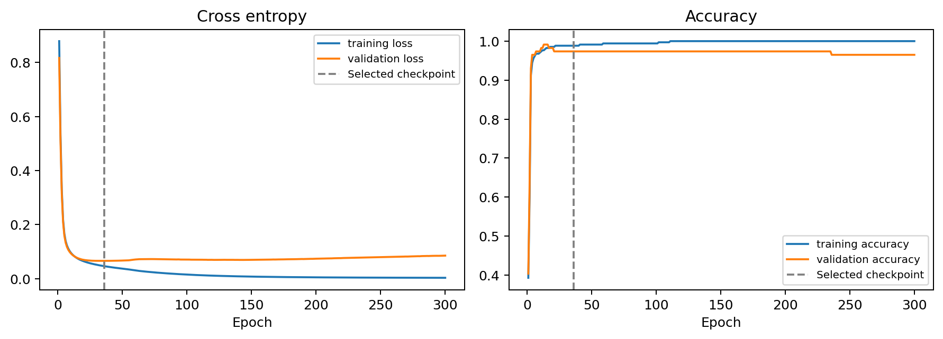
Figure 4 Actual neural training and validation curves with the selected epoch marked
The selected neural network uses one hidden layer with 16 units, alpha = 0.01, learning rate = 0.003 and the epoch 36 checkpoint. At that epoch, training cross-entropy is 0.0458 and validation cross-entropy is 0.0655. Training accuracy is 98.83% and validation accuracy is 97.37%. The plotted losses exclude the L2 penalty on both partitions, making the two curves comparable.
By epoch 300, training loss falls to 0.0028 and accuracy reaches 100%, but validation loss rises to 0.0849 and validation accuracy drops to 96.49%. This pattern indicates late overfitting. Restoring epoch 36 addresses it without consulting test labels. Regularization and the compact architecture also control model capacity. All 300 epochs are shown for diagnosis; only the restored checkpoint is used for final evaluation.
Model | Training F1 | Validation F1 | Validation recall
Logistic regression | 0.9802 | 0.9535 | 0.9535
Random forest | 1.0000 | 0.9647 | 0.9535
Neural network | 0.9841 | 0.9655 | 0.9767

The neural network has the highest validation F1, 0.9655, and recall, 0.9767, so it is the frozen recommendation. Forest F1 is close at 0.9647; logistic regression achieves 0.9535. No model shows strong evidence of persistent underfitting because all achieve high training and validation scores. The forest has the largest final training–validation F1 gap, while the restored neural network avoids the more overfit end-of-training state.

Stage 5 Final evaluation and comparison
The final test set contains 114 observations: 72 benign and 42 malignant. F1 is the primary balanced comparison because it accounts for both missed malignant cases and false alarms. Recall is particularly important when interpreting false negatives, but no clinical cost ratio is assumed. Precision quantifies the reliability of positive predictions, accuracy describes overall correctness and ROC-AUC measures ranking across thresholds.
For malignant as positive: precision = TP/(TP + FP), recall = TP/(TP + FN), F1 = 2TP/(2TP + FP + FN), and accuracy = (TP + TN)/N. All metrics below use the fixed 0.5 threshold except ROC-AUC, which uses probabilities. Values are proportions.
Model | Accuracy | Precision | Recall | F1 | ROC AUC
Logistic regression | 0.9825 | 1.0000 | 0.9524 | 0.9756 | 0.9974
Random forest | 0.9561 | 0.9744 | 0.9048 | 0.9383 | 0.9970
Neural network | 0.9737 | 0.9756 | 0.9524 | 0.9639 | 0.9960

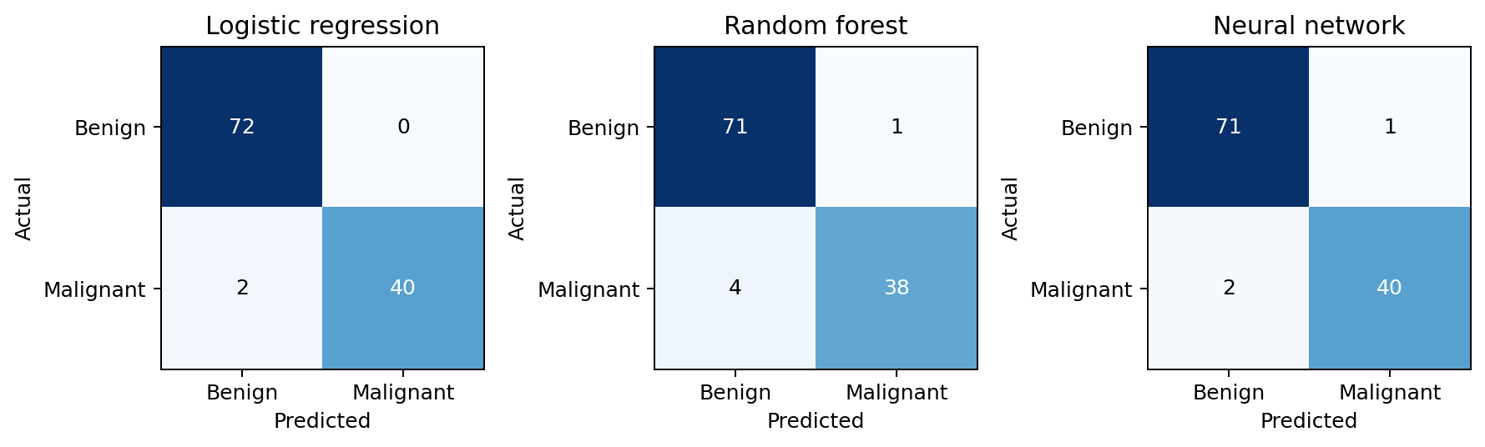
Figure 5 Test confusion matrices with actual classes as rows and predicted classes as columns
Logistic regression correctly identifies 40 of 42 malignant cases and all 72 benign cases. The neural network also detects 40 malignant cases but incorrectly flags one benign case. Random forest misses four malignant cases and incorrectly flags one benign case. These counts reconcile with 114 test observations per model.
For example, neural F1 = 2 × 40 / (80 + 1 + 2) = 80/83 = 0.9639, and accuracy = (40 + 71)/114 = 0.9737. The always-benign baseline achieves 72/114 = 63.16% accuracy but zero malignant recall and F1, showing why overall accuracy alone is inadequate.
The 95% Wilson interval for malignant recall is 0.8421–0.9868 for both logistic regression and the neural network; forest recall has interval 0.7793–0.9623. The small number of malignant test cases leaves substantial uncertainty. These are single-proportion intervals, not paired significance tests or evidence that the models differ significantly.

Discussion
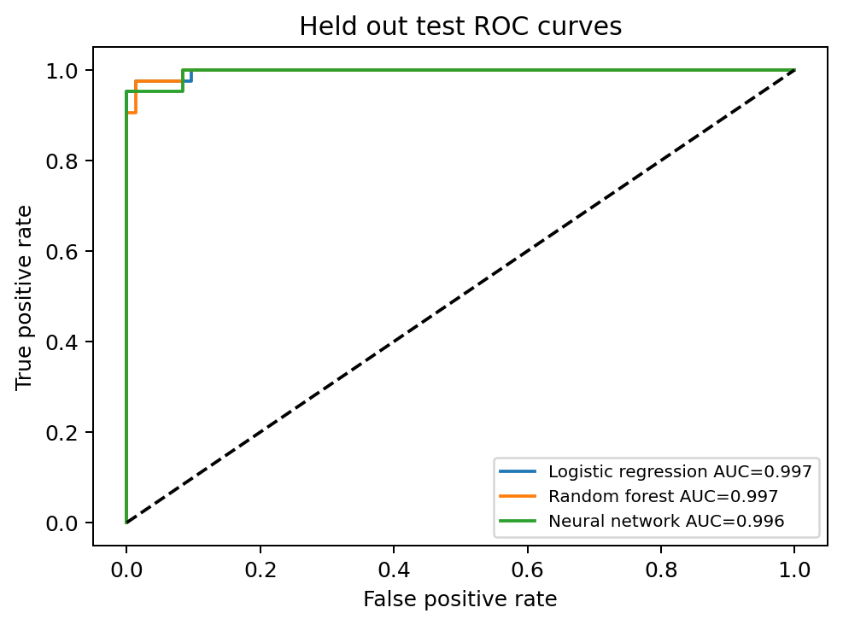
Figure 6 Final test ROC curves
Logistic regression achieves the strongest observed test performance: F1 = 0.9756, accuracy = 98.25% and ROC-AUC = 0.9974. The selected neural network achieves F1 = 0.9639 and accuracy = 97.37%. Both miss two malignant cases. Their difference is one additional neural false positive, so the test result does not support a broad claim that one algorithm is superior.
The neural network remains the recommendation from the prespecified development rule because it had the highest validation F1 and recall before test evaluation. The test scores assess that decision; they are not used to choose another winner. Logistic regression is nevertheless the strongest test comparator and an attractive simpler alternative for a future study. Its close performance suggests that the supplied measurements can be separated effectively by a regularized linear decision boundary.
The forest’s perfect training fit and weaker validation and test F1 are consistent with greater variance. Its high ROC-AUC indicates good ranking, but its fixed-threshold recall is lower. This distinction shows that ranking quality does not guarantee the desired classification tradeoff at a particular threshold. A future threshold study would need separate development data and an explicit cost objective.
The validation F1 difference between the neural network and forest is only 0.0008. That margin is too small to treat as decisive evidence. The neural checkpoint and architecture were selected using the same validation records, which introduces selection optimism. One seed and one small retrospective dataset cannot establish stability across samples or performance in other institutions. No demographic variables are available, so subgroup fairness cannot be evaluated.

Conclusion
The project completed data integrity checks, training-only EDA, a disjoint 60/20/20 split, three classification models, hyperparameter searches, neural epoch monitoring and final test evaluation. Training-only analysis identified strong relationships in size and concavity measurements and substantial redundancy among some size features. Scaling was used for scale-sensitive models, while all valid observations and all 30 predictors were retained.
The 16-unit neural network at epoch 36 was selected by the validation protocol. Restoring that checkpoint prevented the late overfitting visible after continued training. On the final test set, it detected 40 of 42 malignant cases. Logistic regression achieved the highest observed test F1 with the same malignant recall and one fewer false positive. These results demonstrate a complete workflow rather than readiness for clinical use.
Future work should repeat the split with several seeds, use nested cross-validation for model-selection stability, examine probability calibration and evaluate an external dataset. A threshold policy should be developed only after defining the relative cost of missed malignancy and false alarms. Subgroup evaluation would require suitable demographic data. These improvements were not executed in this study.

References
Scikit-learn developers. (n.d.-a). GridSearchCV. https://scikit-learn.org/stable/modules/generated/sklearn.model_selection.GridSearchCV.html
Scikit-learn developers. (n.d.-b). load_breast_cancer. https://scikit-learn.org/stable/modules/generated/sklearn.datasets.load_breast_cancer.html
Scikit-learn developers. (n.d.-c). Neural network models supervised. https://scikit-learn.org/stable/modules/neural_networks_supervised.html
Wolberg, W., Mangasarian, O., Street, N., & Street, W. (1993). Breast Cancer Wisconsin (Diagnostic) [Dataset]. UCI Machine Learning Repository. https://doi.org/10.24432/C5DW2B

GitHub Link: https://github.com/meshallgh77-rgb/DS471.git

